Parola for Arduino  
Hardware - Bill of Materials and Assembly

## Bill of Materials

|  |  |  |
| --- | --- | --- |
| **Qty** | **Part** | **Description** |
| 1 | PCB | Printed Circuit Board. |
| 1 | Maxim MAX7219 IC | LED controller. |
| 1 | LD-1088 | 8x8 3mm common anode LED matrix display. |
| 1 | 5 pin 2.54 mm single row angled socket connector | Right angle connector (female) cut from longer length. |
| 1 | 5 pin 2.54 mm single row angled pin connector | Right angle connector (male) cut from longer length. |
| 2 | 8 pin DIP IC socket strip | Socket strip cut from longer length, one for each side of the LED matrix. |
| 1 | 62k Ohm resistor | Resistor sized according to rules for Rset in the MAX7219 datasheet – refer to the datasheet for appropriate values. Something close is sufficient as long as all the resistors are the same, as this controls the LED brightness. |
| 1 | 10µF electrolytic capacitor | Electrolytic capacitor |
| 1 | 0.1µF ceramic capacitor | Ceramic capacitor |

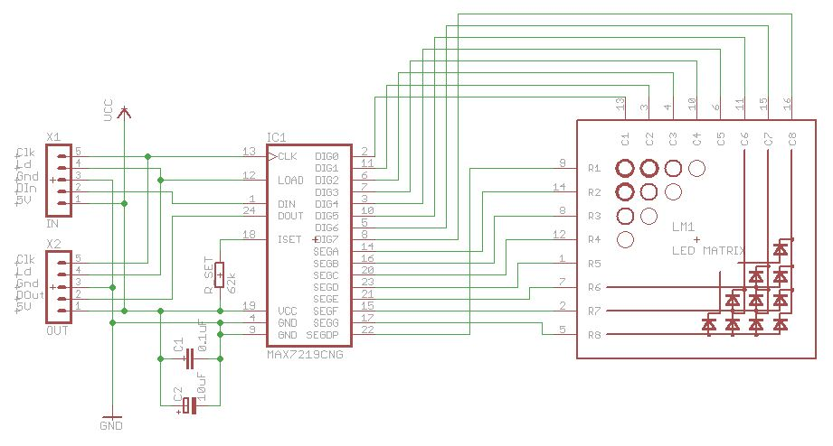

Figure – Hardware Circuit Schematic

## Component Sources

The PCB can be manufactured at Seeed Studio (<http://www.SeeedStudio.com>) using the files available on the project web site. The zip file distributed contains all the data required by this service. PCB manufacturing can be found in the Services menu, and the board size is 30x50 mm.

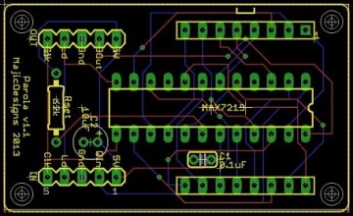

Figure - PCB Layout

Tayda Electronics (<http://www.taydaelectronics.com>) is an inexpensive source for all the components

* MAX7219 ICs (Part number A-1018)
* LED Dot Matrix 8x8 Display Red 3mm Common Anode (A-1013)
* 40 Pin 2.54 mm Angle Single Row Pin Header (A-199)
* 40 Pin 2.54 mm Single Row Right Angle Female Pin Header (A-1012)
* 40 Pin DIP SIP IC Sockets Adaptor Solder Type (A-1605)
* 62k Ohm 1/4W 5% Carbon Film Resistor (A-2122)
* 10µF 50V 105C Radial Electrolytic Capacitor 5x11mm (A-4554)
* 0.10µF 50V Multilayer Ceramic Capacitor (A-214)

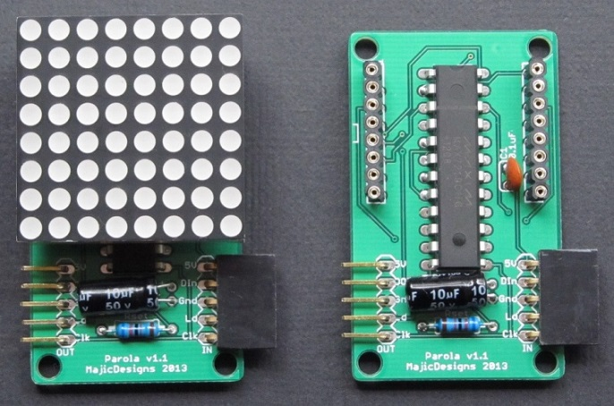

Figure - Completed hardware

## Assembly Instructions

All items, except for the edge connectors and the LED matrix, are straightforward to assemble. The recommended order of assembly is:

1. Edge connectors
2. Resistor
3. Integrated Circuit – insert as per silk screen orientation, without IC socket
4. Capacitors – note polarity on the 10µF electrolytic capacitor
5. LED matrix, with socket attached

### The Edge Connectors

This process is easiest if two modules are assembled concurrently.

1. Cut 5 pins from the female edge connector. The strip need has to be separated in the middle of the 6th connector. Use sandpaper or a file to neaten up the jagged cut end.
2. Do the same for the male connector. In this case, the separation is between pins.

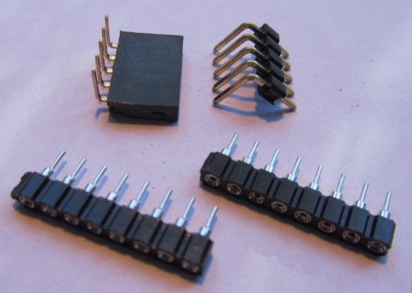

Figure - Connectors cut to size

1. Remove the angled header pins from their plastic matrix. They should slide out relatively easily. If they don’t, use side cutters to break away the plastic material. You will be left with 5 right angle pins with one leg slightly longer than the other.

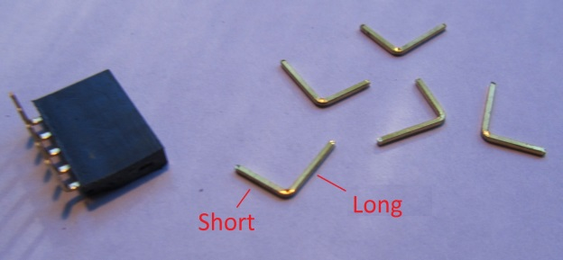

Figure - Separated pins

1. Insert the shorter end into the socket so that the final subassembly looks like Figure 6 below.

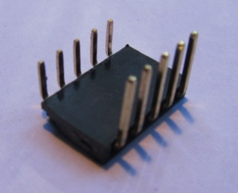

Figure - Connector subassembly

1. Insert the connector subassembly into 2 inverted PCBs laid alongside each other, supported by the long socket strips. This ensures that the connector assembly remains flat and parallel to the PCB, as the spacers and connectors are the same thickness.

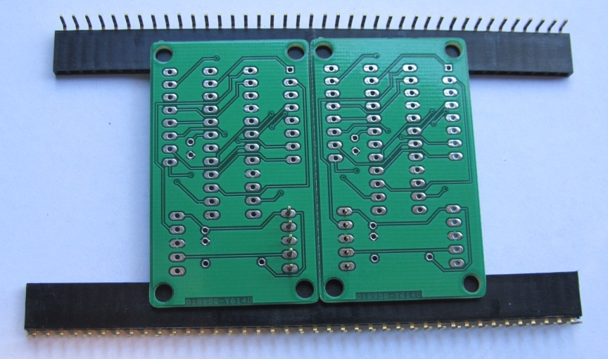

Figure - PCB supported for connector soldering

1. Double check that the PCBs and the connectors are inserted in the same direction as modules already assembled, and that the PCB is really upside-down (no silk screen text visible).
2. Check that the two PCBS are lying parallel to each other, either touching or with a consistent small (< 1 mm) gap along the common long edge. Ensure this gap remains the same while you solder the edge connector in place.

### The LED Matrix

1. Attached the IC socket strips to the LED matrix pins. This makes it easier to insert the pins into the PCB as they remain straighter and stiffer than the ‘bare’ pins. Ensure they are fully inserted.

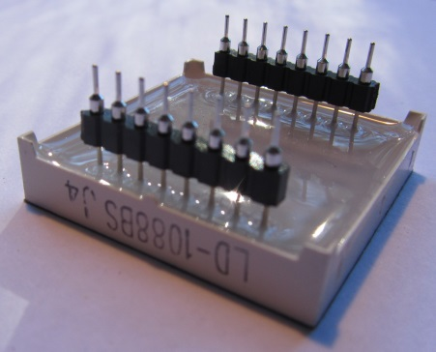

Figure - LED matrix inserted into socket strip

1. One edge of the LED matrix has a small plastic square tab on the lower edge. This should be aligned with the square mark silkscreened near the edge of the PCB.

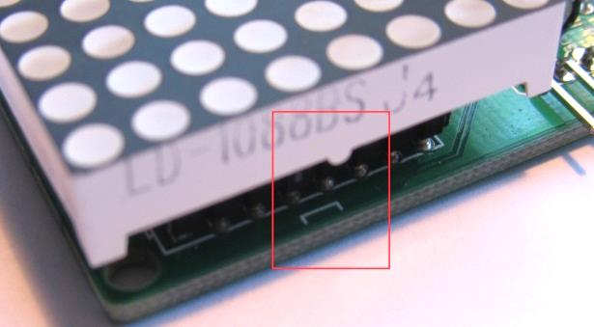

Figure - Alignment tab and PCB silkscreen

1. Insert the LED matrix with sockets connected into the PCB.
2. Invert the PCB and press down on the back to ensure that the pins are pushed into the PCB holes as far as they will go. This ensures that the faces of all the matrices will be flush when the modules are connected side by side.
3. While keeping pressure, solder the four corner pins to lock it in place. Check that the matrix is correctly inserted before completely soldering all the remaining LED matrix pins to the PCB.